Stream Buffer:
- Debugging: Check if this current pc is the same as next or last pc
- Fix behavior of SB state and output valid if same or not same.

Lower priority queue:
- Combine Gshare with perceptron
- Add BTB
- Move branch predictor outside Hazard controller

Register Renaming + OoO:
- For struct we need flush and stall functions. Dill.
- Change all pass through registers to support struct feature.
- Branch Stack to be worked on.
- Finish Scheduling Register.
- Refactor Decoding Stage Glue Circuit.
- Move forward unit to ALU.
- Finish pass through from Reg file to ALU.
- Write back sign goes into instruction queue and register file.
- In-order commit.
- Double check register names in decoder + reg file(Numbers or names)
- Check only correct instructions get renamed(check decode.valid)
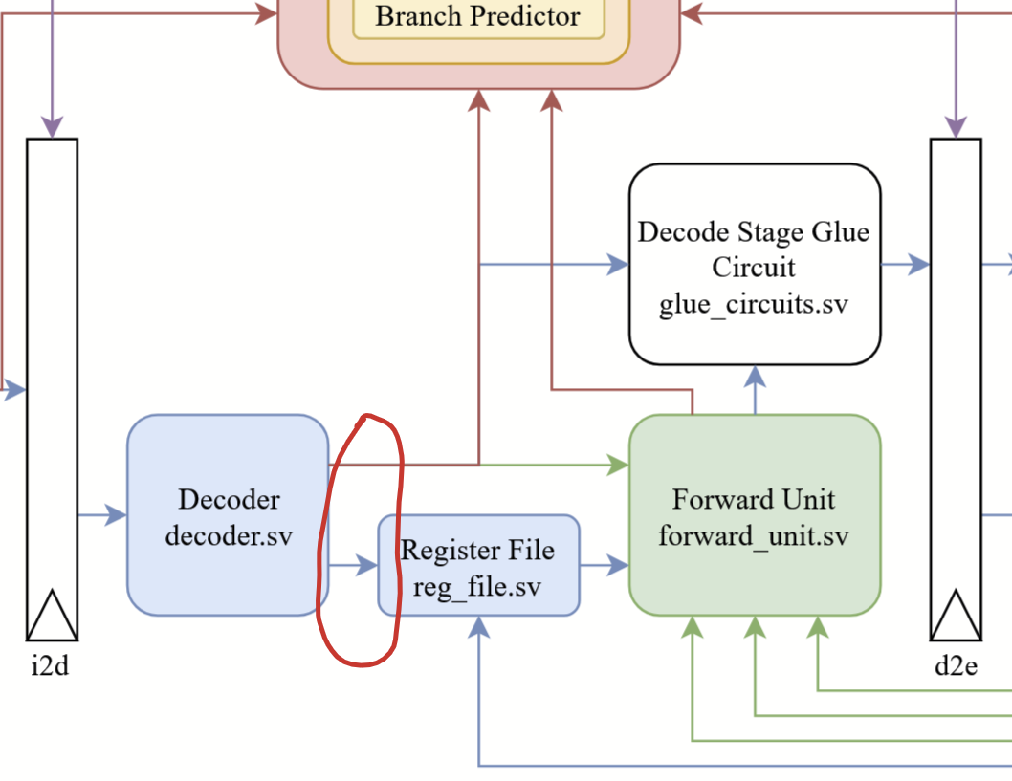

Link to Performance Spreadsheet: https://docs.google.com/spreadsheets/d/10vk0SH0romYoVHbtAzvUSeWrmthFKUIHgowlYVD3IF0/edit?gid=0#gid=0

Optimization 1: Perceptron

Implementation:
We implemented a perceptron as our branch predictor. We implemented it in the branch controller, replacing the given static or 2-bit predictor.

Process: We first began implementing other branch predictors to get a feel for the optimization. We tried two static predictors, always taken and always not taken. Always taken performed surprisingly well, likely due to the benchmarks generally including many loops, which are usually taken. Always not taken did not perform well in comparison. We also tested a simple bimodal branch predictor, which performed better. The first real complex branch predictor we implemented was Gshare, which performs exceptionally well, especially in smaller benchmarks like the ones we were given. Once we had tested that one, we moved on to the actual branch predictor we had planned on implementing, a perceptron-based branch predictor.
The perceptron’s implementation was fairly straightforward. Though we first decided to design it with multiple modules, we ended up settling for a simpler, single module design. The perceptron’s implementation went smoothly. We implemented it with 1024 perceptrons, weights of 8 bits in width, and a history length of 62, which makes for an optimal training threshold of 134.
Problems: The implementation for this optimization was very simple, once designed the only errors we ran into were syntax related. The perceptron interestingly enough does not have much of a change in performance when changing the history length. CPI goes down marginally with smaller history length but there may be an error or bug that is hindering its performance.
Performance: The perceptron showed large performance gains over the simpler static predictors and bimodal, however its performance was similar or slightly below that of gshare in some benchmarks. We attribute this to the large history length and training threshold of the perceptron, which takes a much longer time to adjust to branch patterns than gshare does.

Performance(w/o 2 way set associative i-cache):
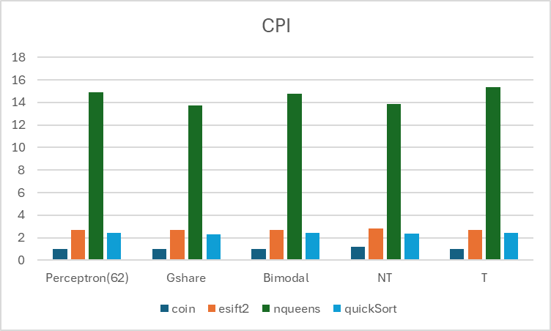
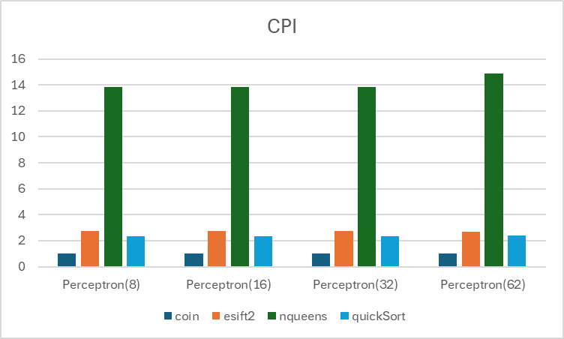
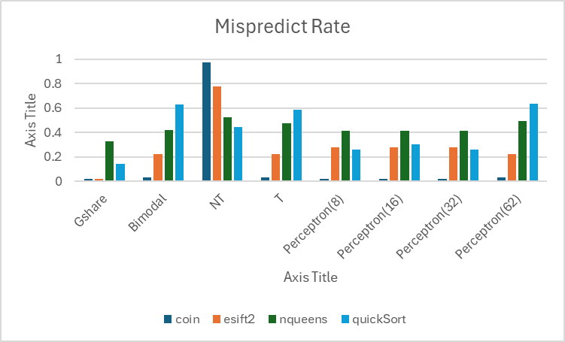

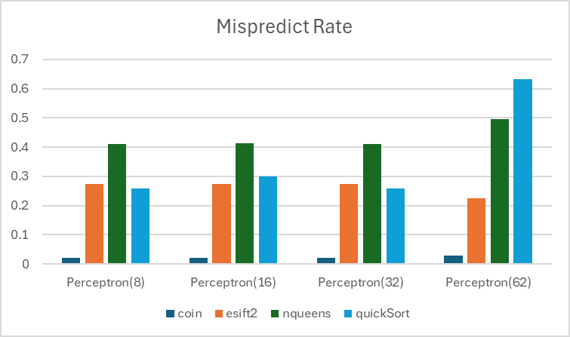

Analysis: The perceptron predictor did not perform as well as we had hoped. Though there were some performance improvements over other predictor types, our perceptron still lost out to GShare dramatically. This could be due to a few factors, the first of which is training time. Our perceptron, especially at longer history lengths, takes a long time to train, meaning it operates below its full capacity for that duration, which leads to performance losses in short benchmarks such as these. This is partially supported by slight increases in performance with shorter history lengths. Another possible hindrance to performance is our hash function, which XORs the program counter with the GHR does not spread out the indices enough resulting in aliasing between branches.
Optimization 2: Stream Buffer

Implementation: We implemented a next-line prefetching hardware stream buffer.
Process:

Problems:
Performance:
Analysis:

Register Renaming

Implementation of this optimization was a much larger hurdle than the perceptron. Initially we had planned to implement this along with out of order execution, meaning we were developing both simultaneously. Our plan was to add two more stages to the pipeline. One for the instruction queue and one for the register read process. The register renaming would happen immediately after the decoder, so decoded instructions could immediately have their registers renamed and be put into the instruction queue. We worked on implementing all of these parts at the same time, meaning that once we realized we were running out of time and needed to drop working on out of order execution and pivot to only implementing just register renaming we had many partially thought out and partially completed parts to extract from each other.

While possibly functional, as determined by painstakingly tracing through every line of code by hand with test cases, the register renaming scheme does not work as of yet due to many syntax and compile time errors
The implementation of this optimization was disorganized and through a better planning phase and earlier start on the project could have possibly worked. The decision to rush into the writing of the code without the overall implementation details having been decided led to the need to drop out-of-order execution out of necessity due to the time constraints we worked under.

Below are diagrams depicting an overview of the design of the processor’s register renaming and out of order execution optimizations. Additionally, there is a photo of the
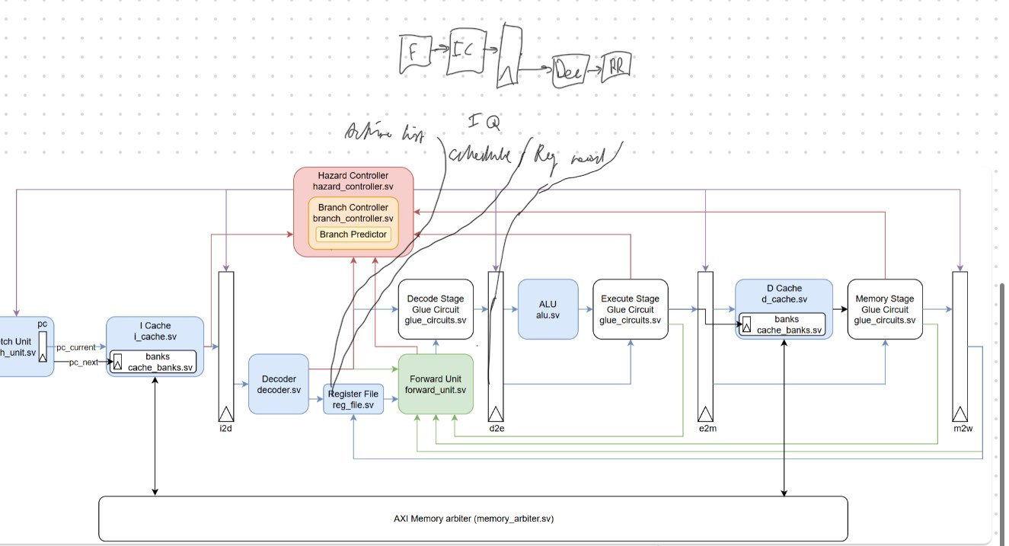
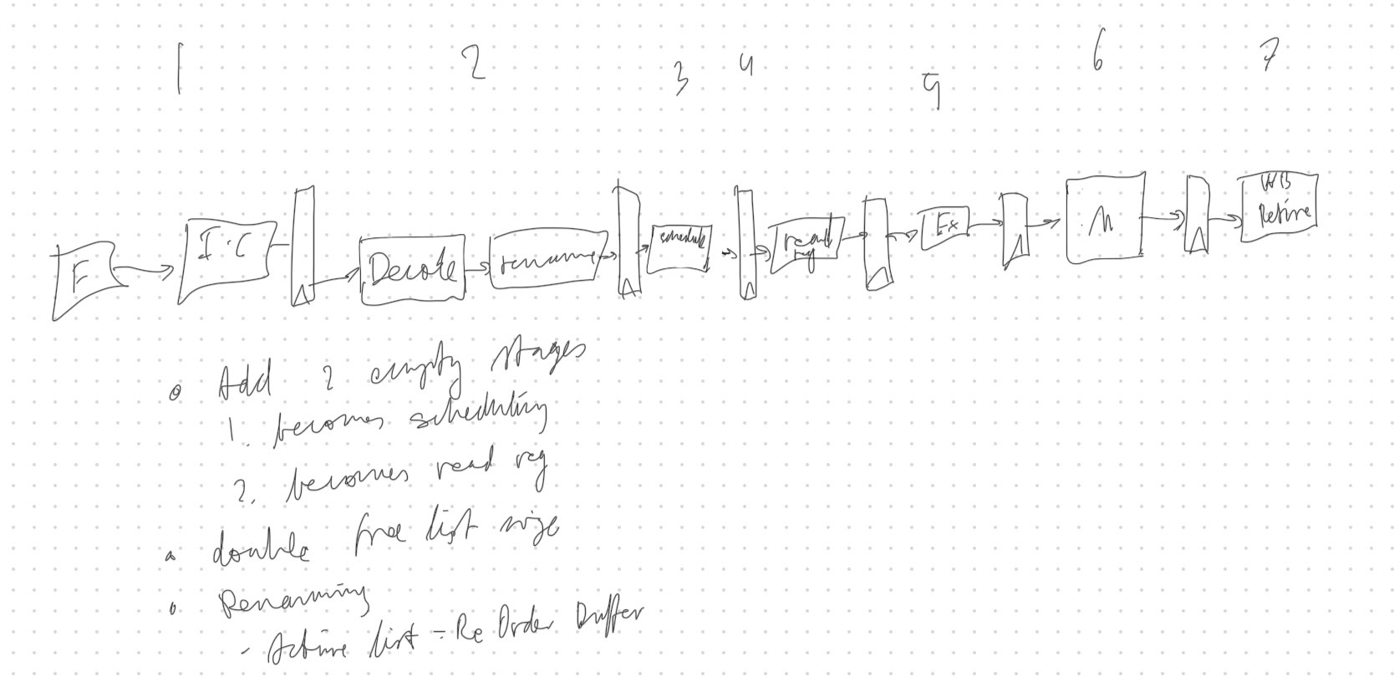
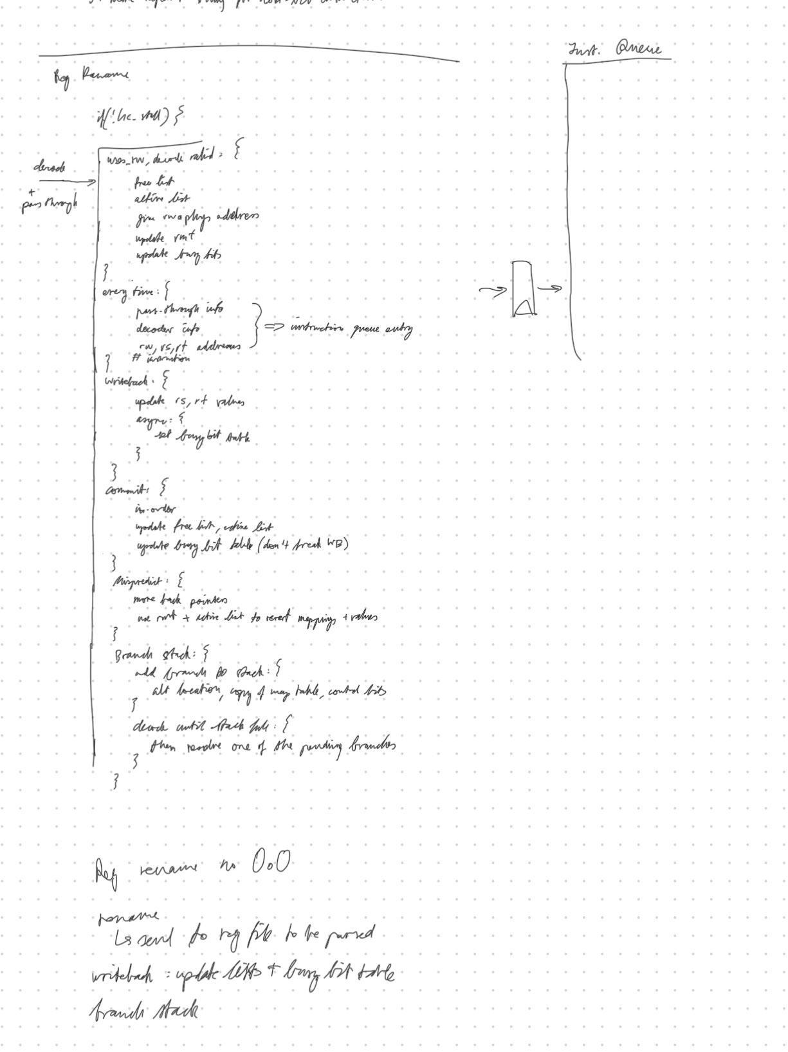

Optimization 4: Out of Order Execution

Implementation: We attempted implementing this optimization, however we had to cease working on it due to time constraints. It is currently in an incomplete state. The implementation was supposed to include two additional pipeline stages to separate the instruction queue and register read

Process: We began working on this optimization after we had finished successfully implementing our perceptron branch predictor. We only partially completed this optimization as we ran out of time.

Problems: We were unable to implement this due to time constraints
Performance: None
Analysis: N/A

